DISTRICT X SPRING CONVENTION
Tuesday, March 29, 2022
SUNNYVALE GARDEN CLUB
Welcomes you to: “Spring into Sunnyvale”

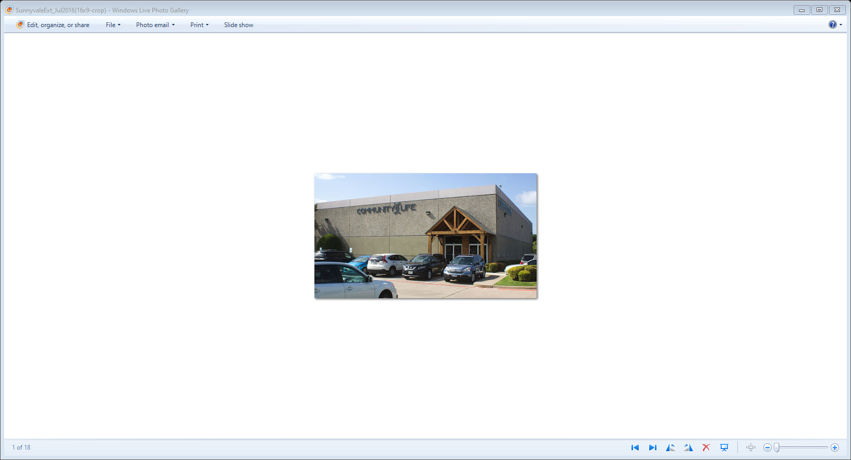
LOCATION:
Community Life Church
610 US-80 E
Sunnyvale, Texas 75182
Registration: 8:30 am to 10:00 am
Board Meeting: 9:00 am to 10:00 am
Meeting Starts At: 10:00 am
REGISTRATION FEE:
Luncheon and Program: $35.00
After March 11 $40.00
No Refunds after March 21

PROGRAM: Bill McKinley AIFD, CFD ICPF
Benz School of Floral Design
Driving Instructions:

From: Highway 80 East
Exit Collins Road
Stay on US 80 East
Frontage Road

From: Highway 80 West
Exit Collins Rd Turn Left
Turn Left Onto US 80 East
Frontage Road

Stay on US 80 East Frontage
Road for about 2.0 miles
Church is on the Right
Texas A&M University
MAIL REGISTRATION FORM & Check TO:
c/o Joyce Taylor
340 Town East Blvd
Sunnyvale, TX 75182-9122
972-345-4651 joyce2745@att.net

REGISTRATION FORM District X Spring Convention, March 29, 2022
One Registration Form needs to be filled out for each individual attending
Amount Enclosed: $__________ Payable to: Sunnyvale Garden Club (no credit cards)

P L E A S E P R I N T
NAME: _______________________________________________________________________________________
ADDRESS: ________________________________________ PHONE # ___________________________
CITY: _______________________________________________STATE:____________ZIP:______________
E-MAIL: ________________________________________________________________________________
CLUB(S): ________________________________________________________________________________

INFORMATION FOR CREDENTIALS REPORT (PLEASE CHECK ALL THAT APPLY)

CLUB: President ___ Delegate ___ Alternate ___ Member___
COUNCIL/FORUM: President ___ Delegate ___
DISTRICT: Officer ___ Chairman ___ Charter Member ___
STATE: Officer ___ Chairman ___ Trustee ___
REGION: Officer ___ Chairman ___ Representative ___

NATIONAL BOARD: ____
LIFE MEMBER: District X ____ State ___ Regional ___ National ___
FORMER STATE PRESIDENT: ____ FORMER DISTRICT DIRECTOR ___
FORMER COUNCIL/FORUM PRESIDENT: ___

FLOWER SHOW JUDGE: Master ___ Life ___ Accredited ___ Student ___ Emeritus ___ Instructor ___

LANDSCAPE DESIGN CONSULTANT: ___ GARDEN STUDY CONSULTANT: ___

TEXAS DESIGN CONSULTANT: ___ TEXAS MASTER GARDENER: ___

TEXAS MASTER NATURALIST ___ ENVIRONMENTAL CONSULTANT: ___
FIRST TIME ATTENDING DISTRICT X CONVENTION: ___ (Y/N); GUEST: ___ (Y/N)

